Hastings Public School rainforest project – September 2011

PROBLEM –
Taro (Elephant Ears) weed is invading the wetland
at the northern end of the school oval, behind the gazebo.
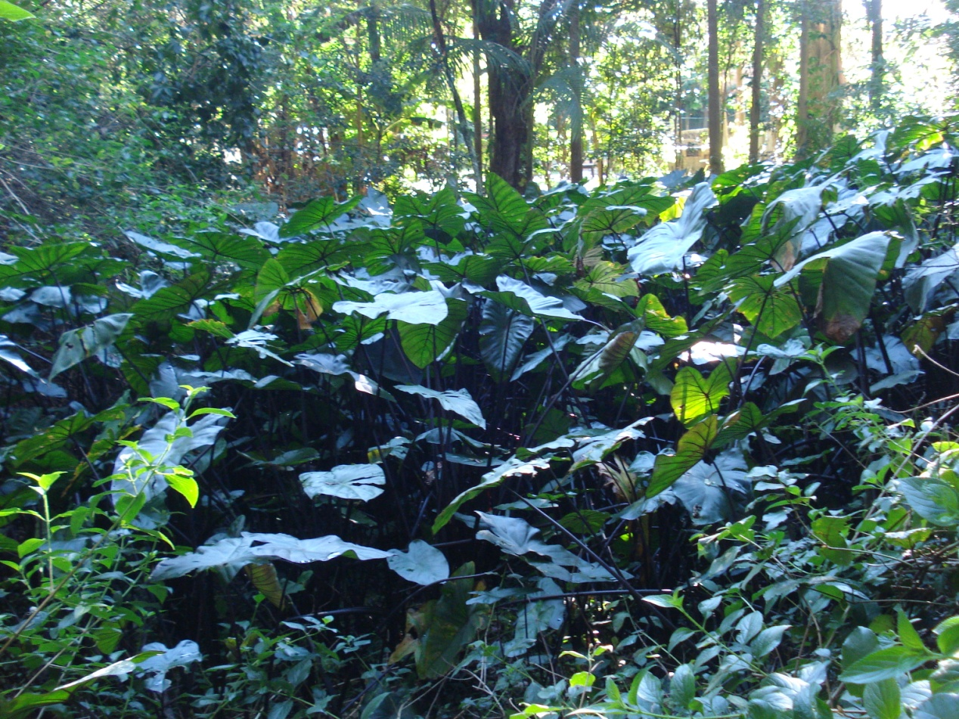

SOLUTION –
Secure funding from the NRMA Community Grants program
to employ a team of professional bush regenerators.
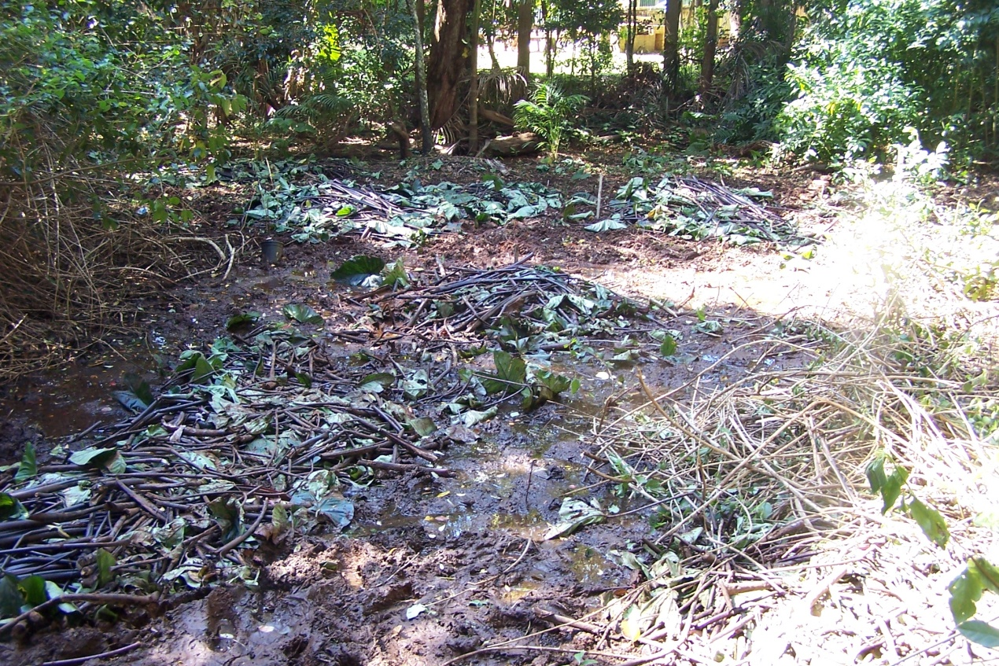
PROCEDURE -
Kelly Benson and the ‘Wild Things’ crew cut Taro vegetation,
dug up rhizomes from the mud and bagged any invasive roots.

The bags were removed from the wetland by the ‘Environment Friends’.

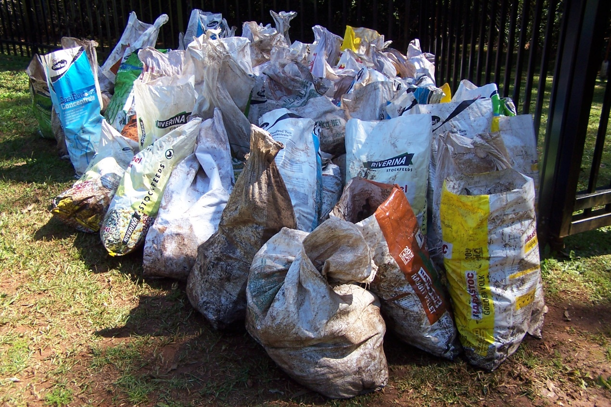

Landcare volunteers loaded the trailer and took the Taro to the tip.

Port Macquarie-Hastings Council paid the tip fee for the bags of weeds.

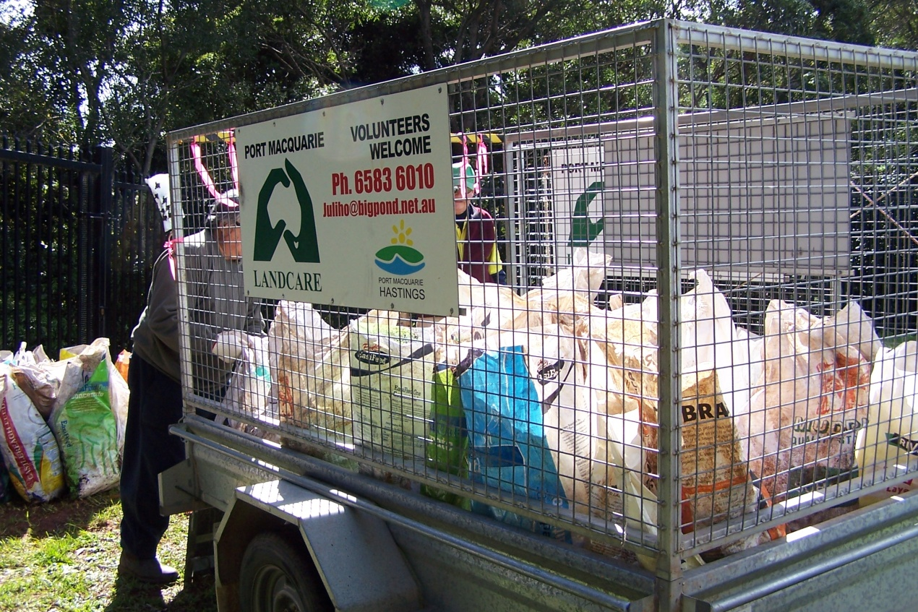

A TRUE TEAM EFFORT ON THIS MARVELLOUS PROJECT!

